Recommended time: 1 hour
The hotel has a list of guest details (guestdetails.csv) and rooms (room.csv).
Create a relational database to book hotel rooms as follows:
2.1Produce an entity relationship diagram for the database.
Consider the need for a linking table that includes the room number, booking date, check-in time, and check-out time.
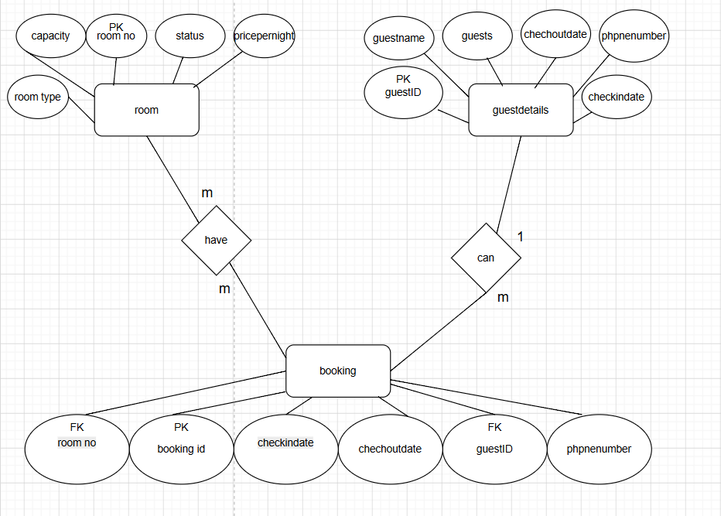
2.2 Identify and record in your data dictionary:
a) keys
b) fields
c) data types
d) validation of data

Recommended time: 1 hour 30 minutes
1. Table: GuestDetails
Field Name | Key Type | Data Type | Description | Data Format | Range | Validation Rules
GuestID | Primary Key (PK) | VARCHAR(10) | Unique system identity code for each guest record | G### (e.g., G001) | G001 - G999 | Not Null, Unique, Alphanumeric format
GuestName | None | VARCHAR(100) | Full legal name of the hotel customer | Text string | N/A | Not Null, Alphabetic letters and spaces only
PhoneNumber | None | VARCHAR(20) | Contact mobile/telephone communication handle | Numeric digits | 10 - 15 numbers | Numerical characters only, no symbol strings
CheckInDate | None | DATE | Scheduled arrival calendar timeline entry state stamp | YYYY-MM-DD | Valid Date Range | Not Null, Structural historical alignment constraint
CheckOutDate | None | DATE | Scheduled departure calendar timeline entry state stamp | YYYY-MM-DD | Must be > CheckInDate | Not Null, Multi-day transactional validation check
Guests | None | INT | Total headcount size occupying the assigned room asset | Integer values | 1 - 6 individuals | Not Null, Enforced configuration bounds >= 1
2. Table: Room
Field Name | Key Type | Data Type | Description | Data Format | Range | Validation Rules
RoomNo | Primary Key (PK) | INT | Unique identifier code for each individual hotel room unit | Integer key | 101 - 500 | Not Null, Unique, Positive integer values only
RoomType | None | VARCHAR(50) | The functional structural category classification layout | Text choice | Single Room, Double Room, etc. | Not Null, Matching standard inventory categories
Capacity | None | INT | Maximum permissible population count for safety layout | Integer volume | 1 - 6 capacity | Not Null, Must scale as positive whole integers >= 1
PricePerNight | None | DECIMAL(10,2) | Financial cost rate applied per transaction night cycle | Numeric currency | 100.00 - 5000.00 | Not Null, Strict positive monetary decimal boundaries
Status | None | VARCHAR(20) | Current live state inventory condition tracking tag | Text category | Available, Booked | Default set automatically to 'Available' entries

3. Table: Booking
Field Name | Key Type | Data Type | Description | Data Format | Range | Validation Rules
BookingID | Primary Key (PK) | INT | Unique auto increment tracking handle code | Integer token | 1 - 999999 | Not Null, Unique, Automated dynamic auto-increment
GuestID | Foreign Key (FK) | VARCHAR(10) | Maps reservation record directly back to master guest profile | G### code | Matches GuestDetails | Not Null, Validates relational cascade mapping paths
RoomNo | Foreign Key (FK) | INT | Maps reservation record directly back to target room profile | Integer key | Matches Room | Not Null, Validates relational cascade mapping paths
BookingDate | None | DATE | Calendar system log transaction registry date tracking stamp | YYYY-MM-DD | Live transaction date | Not Null, Generates using current date automatically
CheckInTime | None | TIME | Mandatory operational time window entry rule check | HH:MM:SS | Standard operational hours | Not Null, Time verification format validation
CheckOutTime | None | TIME | Mandatory operational time window exit rule check | HH:MM:SS | Standard operational hours | Not Null, Time verification format validation

2.3
Write SQL statements to create and join the tables identified in the entity relationship diagram.
You must save a screenshot of the SQL statements for your assessor.
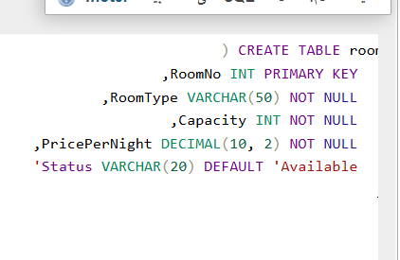
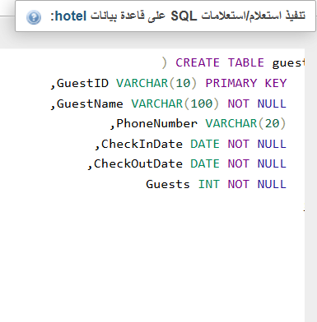
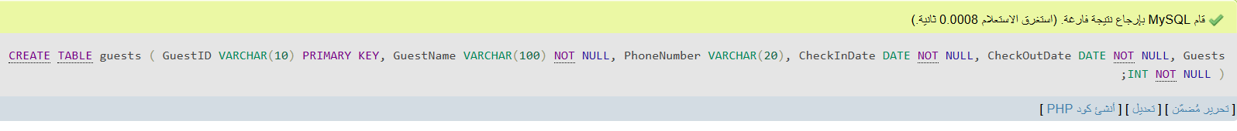
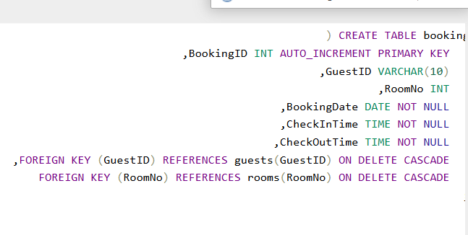
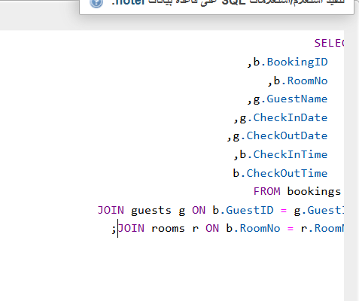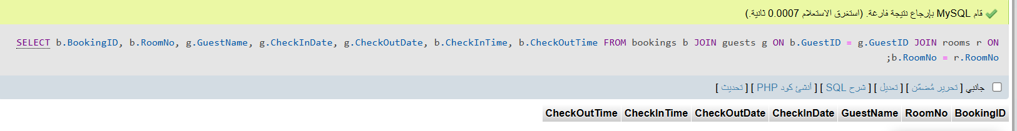
2.4 Populate the database from the guestdetails.csv and room.csv data files provided.
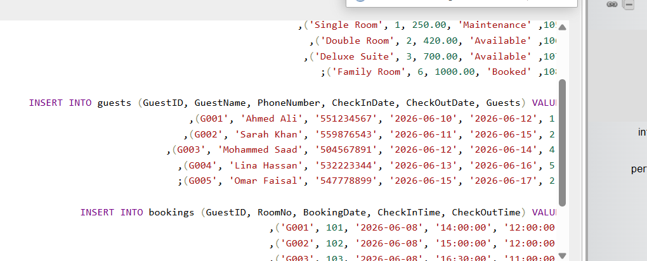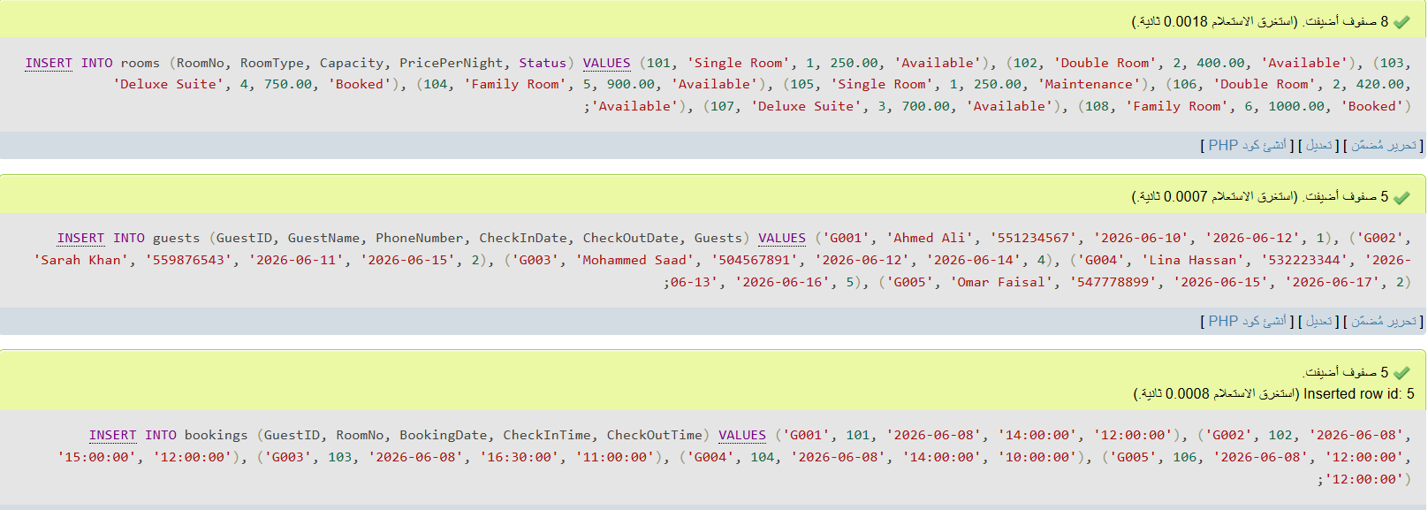

2.5 Write SQL statements that would display:
- a list of room bookings sorted by room number
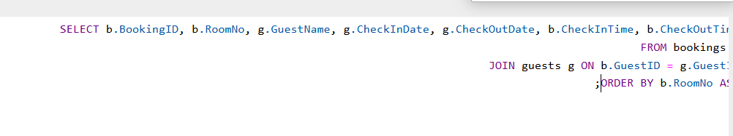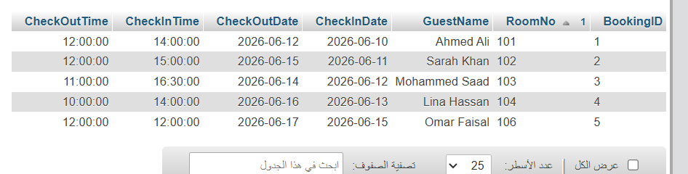
- a list of bookings for a particular guest
